Steps to Fade the use of Safety Behaviors
Step 1. Identify a specific safety behavior you want to fade.
Think of a few situations that make you uncomfortable. Challenge yourself to do those for 10-30 minutes and take notes. It may be hard, but you will learn a lot about safety behaviors you can work on.

Step 2. Choose a strategy to reduce your safety behavior use.
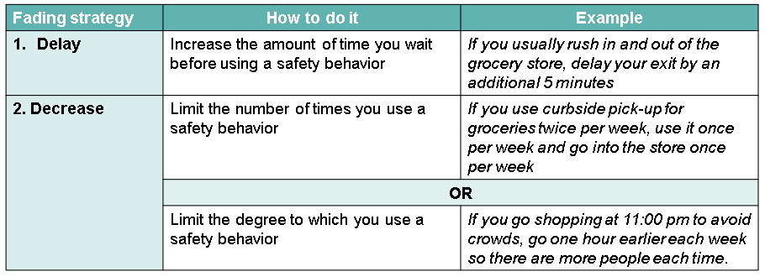
The main idea is to engage in uncomfortable activities while limiting how much you use a safety behavior. Do your best to remain in situations without using your safety behavior more than you planned. Remember, leaving a situation because of distress is a safety behavior, too!
Step 3. Track your progress.
Find situations during the week to fade your safety behavior. Track how much you are using it in each situation to see the progress you are making toward your goal.
Step 4. Eliminate your safety behavior.
Once you achieve your first goal, use the same strategies in Step 2 to continue reducing that safety behavior. Continue tracking and updating your plan until you feel comfortable and safe in those situations without using safety behaviors at all.

Questions to determine if we’re using a safety behavior
- Is this behavior reducing my anxiety temporarily (i.e., only in the short-term)?
- Do I need to use this behavior again or more frequently because the feeling of threat isn’t changing?
- Does this behavior actually increase my safety or just my feeling of safety?
- Would my emotions be more intense if I was not engaging in this behavior right now?
- Could this behavior prevent me from learning that I can handle difficult situations?
- Would I feel less flexible about doing this difficult thing if I couldn’t use this safety behavior?

